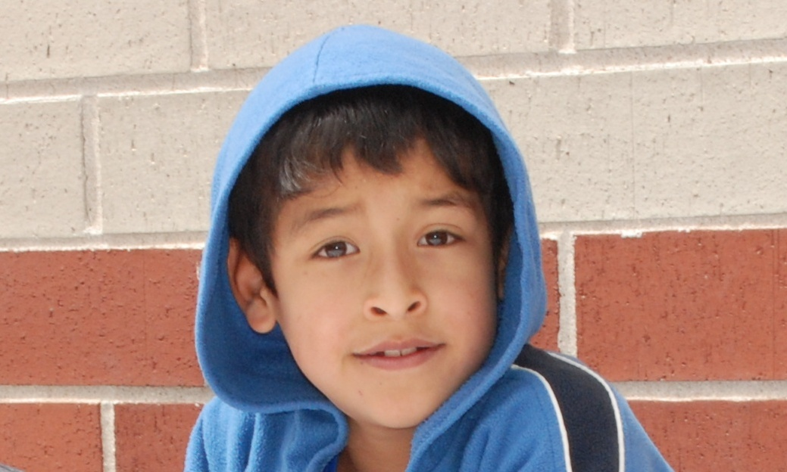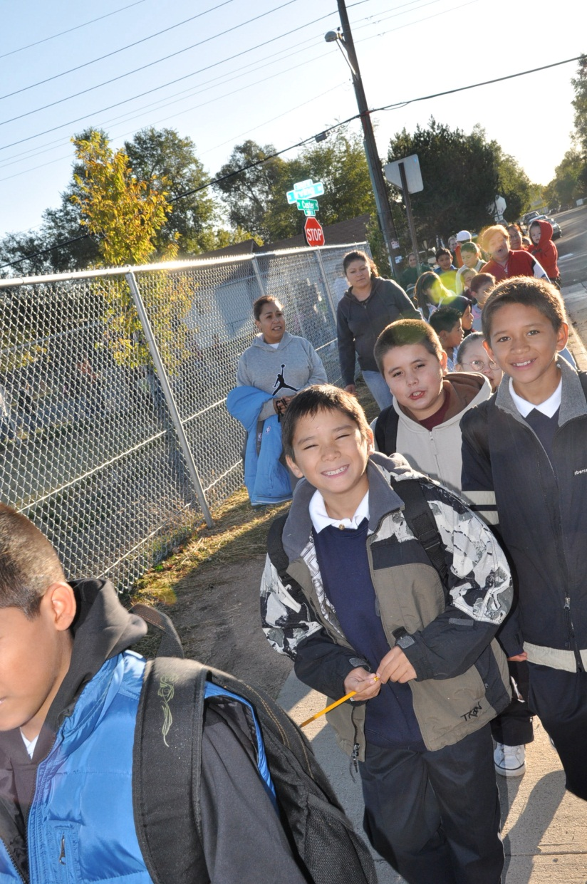

Contact your ***School Nurse***for more information and to apply for the

Denver Public School Dental Program.

**Does Your Child Need**

**Dental Services?**

Dental Services are provided in collaboration with Denver Public Schools Department of Nursing and Student Health Services and Denver Health Dental Clinics.

Your child may qualify for our

new dental assistance program

if they meet any of the following:

• Qualify for free or reduced price lunch

• No dental insurance

• Unable to afford dental care co-pays

**Services May Include:**

• Dental Examinations

• Dental Cleaning

• X-rays

• Fluoride Treatments

• Treatment for Painful Teeth

• Tooth Decay

• Tooth Injuries

